Ecosystem Approach to Fisheries Management

# **course notes**

CONTENTS

Introduction 2

Unit 1: Threats to sustainable fisheries 4

Unit 2: Fisheries management 11

Unit 3: Ecosystems 17

Unit 4: Ecosystem Approach to Fisheries Management (EAFM) 24

Unit 5: Fish biology 33

Unit 6: Local coastal fisheries 41

UNIT 6a. Papua New Guinea Coastal Fisheries 41

UNIT 6b. Solomon Island Coastal Fisheries 54

Unit 7: Governance 61

Unit 7a. Papua New Guinea coastal fisheries governance 61

Unit 7b. Solomon Island coastal fisheries governance 71

Unit 8: Fisheries assessments 76

Unit 9: Implementing an EAFM Plan 87

Unit 10: Compliance, Monitoring and Plan review 100

GLOSSARY TEST (Assessable) 108

# Introduction

These course notes comprise detailed teaching materials to support delivery of each of the ten Ecosystem Approach to Fisheries Management (EAFM) course units outlined in the curriculum and unit plans document. The course notes are also designed to be provided to students as essentail course reading material if they are to get full learning value from the course. The accompanying powerpoint presentations are developed as tools for teachers/lecturers to deliver and teach each unit, however they do not contain the full details included in these course notes. Teachers who are new to this subject area will need to be familiar with the content of these notes and draw on these to complement the powerpoint presentations in ensuring comprehensive delivery of the course.

This course is designed to be able to be delivered either in full as an EAFM course, or as individual units as needed by teachers/trainers to complement and value-add to existing courses. It is also developed to be able to be delivered to a range of audiences with different levels of experience and training. That is, within each unit teachers can be flexible in the material delivered (and not delivered). To facilitate this, we have placed advanced material in separate sections within each unit. To assist with the flexible learning approach teachers should ask students about their previous experience and/or training with management, science, fisheries or policy development and tailor the level of course accordingly. It may also be useful to ask students what they want to achieve in this subject and refer to this during the training.

The course includes many different activities to help in the teaching process and to also provide diverse learning strategies for students. The course uses as many examples as possible and as local as possible to help with learning. However, teachers are encouraged to complement the teaching examples and activities provided with some of their own.

The course is focused firstly around providing basic background knowledge that underpins the use of the EAFM approach and, secondly, learning how to develop an EAFM plan in a step-by-step approach. This second aspect will form the bulk of the course and students will use the steps outlined to develop their own EAFM plan. This will be the major assessment piece for the course. Several course activities are designed to give students time to complete the different steps in developing the plan and templates are provided for use during these activities. While conducting trials of this course it was found that, unless students are advanced, developing the EAFM plan during the course is best done either in pairs or small groups. Also, students should base their EAFM plan on a region of their choosing; one they are familiar with, as well as familiar with the local fisheries issues. If not, there should be published information made available to students that will provide the necessary background for the development of an EAFM plan to occur. Failing this, developing a plan based on a hypothetical situation is reasonable.

There is one core reference that students are expected to use and follow during the course, and two complementary references students should also endeavour to read (see below). Electronic copies of these are provided and where possible, hard copies should be used. Also provided at the end of each unit in these notes are key references and suggested additional reading material that help provide some of the information needed in developing a fisheries management plan, and also to provide more advanced training. Many of these (but not all) are provided electronically so they can be shared with students as appropriate.

**Core reading:**

Secretariat of the Pacific Community. (2010) A community-based ecosystem approach to fisheries management: guidelines for Pacific Island countries. Secretariat of the Pacific Community, Noumea. 65pp. (Ref # EAFM1)[1]

**Complementary core reading:**

FAO. (2005) Putting into practice the ecosystem approach to fisheries. Food and Agriculture Organisation, Rome. 86pp. (Ref # EAFM2)

FAO. (2010) Putting into practice an ecosystem approach to managing sea cucumber fisheries. Food and Agriculture Organisation, Rome. 81pp. (Ref # EAFM3)

# Unit 1: Threats to sustainable fisheries

## Student outcome: understanding of threats to fisheries and why identifying key threats is important

### Activity 1.1: Ask each student to list three (3) potential threats to fisheries on sticky note pads. Lists to be collected and placed on whiteboard/butchers paper on the wall. This list can be referred to throughout the unit. (10 mins)

When describing threats it is important to distinguish between threats and drivers of threats. A threat can be defined as “a person or thing likely to cause damage or danger”. An example of a driver of threats is population growth.

### Internal threats to ecosystems and fisheries

These are generally threats that are more locally-based and therefore it is possible that their impacts can be locally, or nationally, controlled.

* **Locally sourced pollution including downstream (catchment) impacts**

*Ask class for examples of these in their experience (e.g. farming, mining, coastal developments).*

This includes the impacts of pollution derived from local catchments and/or local coastal developments. These threats are locally-based however impacts from similar sources farther away are also relevant but are more externally based threats (see below). Discuss how these can directly impact fishery species (eg. physiological effects (reduced growth & reproduction) of poor water quality or contaminants) or indirectly through habitat impacts. See Box 3 and Table 2 (EAFM1).

* **Destructive fishing**

*Ask class for examples of these in their experience (e.g. trawling, blast fishing, use of poison, smashing of coral to chase out fish – refer to Activity 1.1)*

Discuss how these will impact fishery species primarily through habitat impacts.

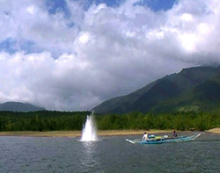

Figure 1.1. Blast fishing using dynamite at a near shore tropical reef.

* **Over-fishing**

*Ask class for examples of these; then group the answers as per the headings below and prompt as per the headings below:*

Two main types of biological overfishing:

1. Growth overfishing – when fish are caught before they have time to grow. Ie. Too many small fish are taken.
2. Recruitment overfishing – reductions in the number of new fish recruits brought about by fishing. Ie. the spawning stock is reduced to the point that spawning and recruitment is affected.

***Retained species including target species and by-product****:* impacts can be a reduction in the numbers of these species, or a reduction in their average size. Include discussion of how larger fish have exponentially more larvae and more robust larvae thereby providing greater potential contribution to the next generation/cohort of fish in the population.

For some species, e.g. Giant Clam, the population needs to be relatively large before successful spawning can occur. So fishing some populations down to a lower, unknown trigger value can mean they are not longer able to reproduce and therefore recruit new individuals to the population (SPC 2010).

Some species, e.g. some snappers and groupers, may aggregate at certain times of the year in large numbers to spawn. There are three potential overfishing problems here:

1. The fish, when aggregating, are particularly vulnerable to fishing so it is easy to take more than the overall population can sustain.
2. Moderate levels of fishing of aggregations may disrupt spawning behaviour and compromise successful reproduction. The effect would be a reduction in the number of baby fish produced (SPC 2010).
3. May alter the sex ratios by selectively removing more of one gender which can also compromise spawning success.

***By-catch species:*** (e.g. in Australia trawl fishing can include ~90% of discarded by-catch). This can alter the fish communities and ecosystem balance (see ecosystem impacts).

*Discussion: Does the class have any knowledge of changes in the catch per unit effort of target species over time?*



Figure 1.1. Example of a destructive fishing method - trawling.

### Activity 1.2: Ask students to consider the following questions as examples and write their own example on sticky note pads with one for the current situation and one for the past situation (eg. grouper average size in 1980s was ~45cm and now is ~30cm). The teacher and/or student then place these on a timeline written on the whiteboard or butchers paper on the wall.

### Discuss local examples of fishing impacts:

### Does the class have any knowledge of changes in average size of fish caught over time?

### Does the class have any knowledge of any changes in species targeted over time and why this occurred?

### Have market prices changed over time?

### Has access to culturally important species changed through time?

### Have there been any changes in the local habitats?

### Have there been changes in where fishing occurs over time? (15 mins)

Then refer students to Table 1 p6 in SPC 2010 (EAFM1) which show some fishing practices and gears that impact on local ecosystems in the Pacific.

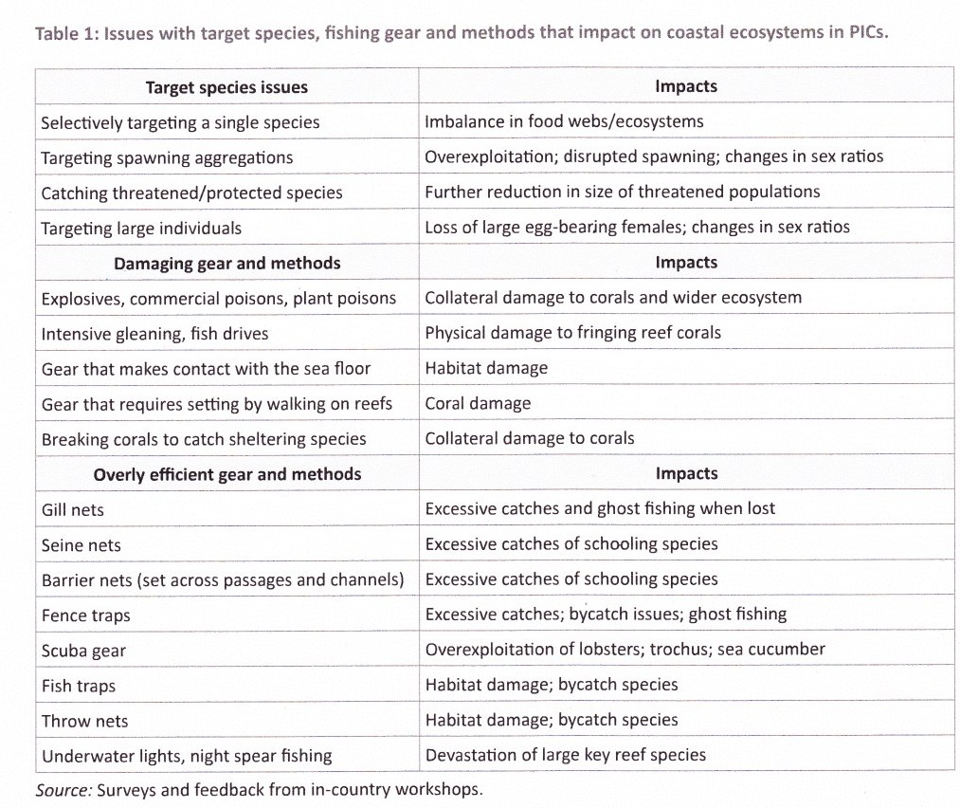

* **Ecosystem impacts**

This can include effects of altering the species composition, effects of taking fish from one trophic level upon the next trophic levels (fishing down the food web), altering or removing different habitat types, or removing larger size classes. A simplified example is provided below to illustrate ecosytem impacts of fishing, however, food webs, food chains and trophic levels are covered in more detail in Unit 4 (Ecosystems).

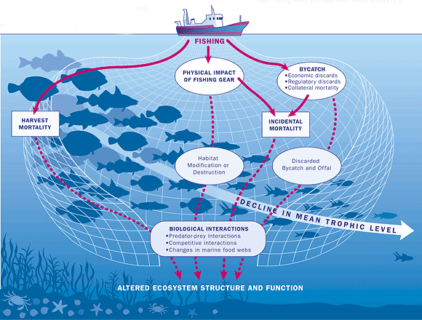

Figure 1.2. Example of ecosystem impacts of fishing.

### External threats to ecosystems and fisheries

In terms of fisheries management there are likely to be threats that are either more difficult to control or beyond your control. Some of these threats may be locally based however the source of some threats may be so far away that non-local co-operation is required. These threats are called “external” threats.

* **Externally sourced pollution including downstream (catchment) impacts**

*Ask class for examples of these in their experience (e.g. farming, mining, coastal developments).*

This potentially includes the impacts of pollution derived from other catchments or even other countries, depending on the oceanic currents. It may, for example, include marine debris such as discarded nets. Discuss how these can directly impact fishery species (eg. physiological effects (reduced growth & reproduction) of poor water quality or contaminants) or indirectly through habitat impacts. See Box 3 and Table 2 (EAFM1).



Figure 1.3. Examples of upstream threats that have downstream impacts on fisheries (p28, EAFM1).

* **Illegal foreign fishing**

These fishers are not allowed to take fish from the local ecosystems but sometimes they do and they can therefore impact the ability of local fishers to take catch sustainably.

* **Climate change**

Of the predicted changes in climate, the biggest potential impacts upon fisheries are likely to be those due to sea surface temperature increases, ocean acidity increases and ocean current changes. The most significant indirect effects will be the projected degradation, fragmentation and loss of coral reefs, mangroves, seagrasses and intertidal flats. As temperatures increase, reproduction, recruitment and growth of fished animals may be impacted and may cause distributions of many marine organisms to shift to higher latitudes and/or deeper waters. Ocean acidification is likely to lead to a reduced ability of shellfish to produce shells and sea cucumbers to produce calcareous spicules which help support their bodies. This may lead to lower populations of these taxa as well as smaller average sizes making them more potentially vulnerable to natural stressors and predators. Increased acidity may also compromise larval development and impair the ability of larval fish to settle, and may alter juvenile behaviour, thereby reducing the number of fish that survive to become adults and therefore replenishment of fished stocks.

Expected changes to currents will change the existing patterns of where larvae settle and, therefore, contribute to stock replenishment. Changing currents will also change patterns of nutrients supplied to coastal habitats e.g. via movement of plankton in upwellings. The expected climate change-associated habitat degradation (e.g. reduced calcification of corals leadings to degraded coral reefs) is likely to impact upon all fished stocks which depend upon those habitats (e.g. in PNG this is ~56% of fish targeted by subsistence fishers). The timeframes for these changes are estimated to be from 25-90 years. The full impact of climate change will vary, however, from location to location and be dependent, in part, on the pre-existing health of the ecosystem being impacted (Pratchett et al 2011)[2].

### Activity 1.3: Ask students to voluntarily rank threats identified during Activity 1.1 from most dangerous to least. Do this as a class discussion and compare with Figure 1.4 below. (10 mins)

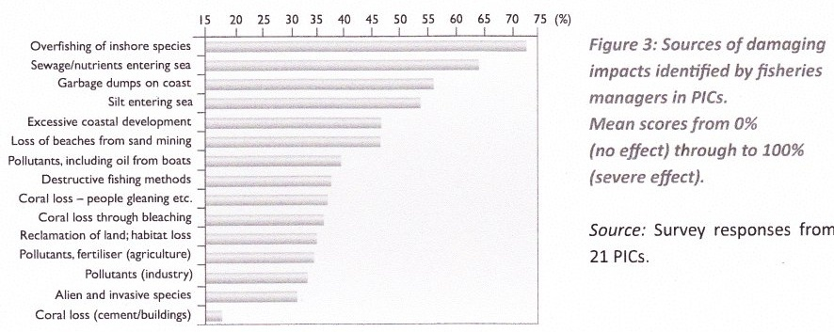

Figure 1.4. Relative importance that Pacific Island Countries apply to all types of impacts upon sustainability of fisheries. Source: EAFM1, p9.

### Shifting ecological baselines

Humans tend to frame norms in their lives over relatively short time frames (i.e. over their own lifetime, at most) and this means that the assessment of what is normal and not normal changes from one generation to the next. (Refer back to Activity 1.2).

The implications for the management of ecosystems is that every new generation see the current situation as the baseline and resource management aiming for sustainability can often aim to sustain the current situation although it may often be already quite degraded.

### DVD: Fish and People – Module 1: Plenty more fish in the sea? (1st half). (7.5 mins)

### The consequences of these threats to fisheries

Marine ecosystem functioning, including maintenance of fished stocks, depends on its structure, diversity and integrity. If any part of the ecosystem (whether habitat or species) are badly impacted, the flow-on impacts (including to fished species) can be significant and can have serious repercussions for people relying on those resources for food or income.

Alteration or disturbance of one or several components of marine ecosystems can have strong effects on higher or lower trophic levels, depending on whether food webs are controlled by resources or by predators (Cury et al 2003). The complete consequences of which are, at best, unknown, or, at worst, catastrophic in the case of fisheries which then collapse e.g. sea cucumber fishery in PNG. One example from a broad area of Fiji shows that as fishing pressure increased the density of predatory reef fish significantly declined, the density of coral-eating starfish significantly increased, and the reef-building corals also sigificantly declined and were replaced by algal species (Dulvy et al, 2004). This is an example of what is called a trophic cascade -

Therefore, to ensure the sustainability of the ecosystem and the fish within it, all parts of the ecosystem (biotic and abiotic, upstream and downstream) must be adequately managed.

### Activity 1.4: Students to form groups of 4-6 people and write down local examples of some social, economic and cultural consequences of negative fishery impacts? One person from each group then presents their results back to the class for discussion. (20 mins)

### Homework: Students interview their parents, grandparents, older neighbour, etc about shifting baselines and their past fisheries experience compared with today.

**Further reading for advanced students (in addition to core course reading list for students in Curriculum):**

Cury, P., L. Shannon, and Y.-J. Shin. (2003) The functioning of marine ecosystems: a fisheries perspective. Pages 103-125 *in* M. Sinclair and G. Valdimarsson, editors. Responsible fisheries in the marine ecosystem. FAO, Rome.

Dulvy, NK, Freckleton, RP and Polunin, NVC (2004) Coral reef cascades and the indirect effects of predator removal by exploitation. Ecology Letters, 7: 410-416.

Jackson, J. B. C., M. X. Kirby, W. H. Berger, K. A. Bjorndal, L. W. Botsford, B. J. Bourque, R. H. Bradbury, R. Cooke, J. Erlandson, J. A. Estes, T. P. Hughes, S. Kidwell, C. B. Bange, H. S. Lenihan, J. M. Pandolfi, C. H. Peterson, R. S. Steneck, M. J. Tegner, and R. R. Warner. 2001. Historical overfishing and recent collapse of coastal ecosystems. Science **293**:629-638.

Pandolfi, J. M., R. H. Bradbury, E. Sala, T. P. Hughes, K. A. Bjorndal, R. Cooke, D. A. McArdle, L. McClenachan, M. J. H. Newman, G. Paredes, R. R. Warner, and J. B. C. Jackon. 2003. Global trajectories of the long-term decline of coral reef ecosystems. Science **301**:955-958.

Pratchett, M. S., P. L. Munday, N. A. J. Graham, M. Kronen, S. Pinca, K. Friedman, T. D. Brewer, J. D. Bell, S. K. Wilson, J. E. Cinner, J. P. Kinch, R. J. Lawton, A. J. Williams, L. Chapman, F. Magron, and A. Webb. (2011) Vulnerability of coastal fisheries in the tropical Pacific to climate change. Pages 493-576 *in* J. D. Bell, J. E. Johnson, and A. J. Hobday, editors. Vulnerability of tropical Pacific fisheries and aquaculture to climate change. Secretariat of the Pacific Community, Noumea.

Sandin, S. A., J. E. Smith, E. E. DeMartini, E. A. Dinsdale, S. D. Donner, A. M. Friedlander, T. Konotchick, M. Malay, J. E. Maragos, D. Obura, O. Pantos, G. Paulay, M. Richie, F. Rohwer, R. E. Schroeder, S. Walsh, J. B. C. Jackson, N. Knowlton, and E. Sala. 2008. Baselines and Degradation of Coral Reefs in the Northern Line Islands. PLoS ONE **3**:e1548.

# Unit 2: Fisheries management

## Student outcome: an understanding of some of the main concepts of fisheries management and tools, and how to gather information to best apply these tools in PNG and Solomon Islands

### Activity 2.1: Ask the class for their views on what is fisheries management? (5 mins)

### The purpose of fisheries management

Fisheries management is the application of fisheries management tools to achieve any stated fisheries management objectives. Put simply, if fisheries are not managed stocks will be depleted until the fishery becomes economically unviable or the stock collapses.

Most fisheries management aims to achieve two or more conflicting objectives which may be biological (e.g. sustainable fish stocks), economic (maximising the catch), social (ensuring a fair share of the catch) and/or cultural (maintaining the ability to use certain species for cultural purposes).

Sustainability usually underpins all other management objectives. Good management practices balance often competing objectives while achieving the goal of sustainability.

Example management plan objectives are:

* Ensure the fishery stock is at or near levels of maximum sustainable economic yield.
* Ensure that traditional resource use is preserved and promoted.
* Maximise the economic and social benefits of the fishery.
* Minimise bycatch and impacts on the ecosystem through habitat damage.

### Fisheries management tools

Fisheries management tools that are used to try to achieve one or more of the identified fisheries management objectives are of two types. Management tools are used to control how much of the fishery population is caught each year in two major ways, either by directly limiting what is caught, or indirectly by placing limits on the effort that can be applied to fishing.

***Input controls*** are tools that indirectly control how much is caught by restricting fishing effort. ***Output controls*** are tools that directly limit catch. Some of these types of management tools have been used by local communities for hundreds of years (EAFM1; EAFM2).

***INPUT CONTROLS***

1. Limiting the number of fishers and/or boats (by licences or other means).
2. Gear restrictions.
3. Limits on the number of fishing days.
4. Temporal (e.g. seasonal closures) or spatial closures.



Example of an input control: restricting the size of fishing vessels and the number of fishermen (Source: EAFM3).

Input control examples – Solomon Islands:

***Fishing gear (method) restriction***

* Ban on destructive fishing practices, eg. Solomon Islands Fisheries Management Bill (draft December 2011)

Division 3, 21. (2) No person shall, for the purpose of killing, taking, stunning, stupefying or disabling fish or in any way rendering fish more easily caught use any chemical, poison or noxious substance or material, whether of manufactured or natural origin, dynamite or explosive substance or device.

* Ban on the take of all sedentary animals at night using lights and/or SCUBA and hookah.

***Spatial closures***

* No fishing within the Inner Honiara Harbour.
* MPA on Tetepare Island and the Roviana/Vonavona MPA network with a ban on all harvesting

***Species restrictions***

* Ban on the take and consumption of turtles.
* Sea cucumber harvest closure (until 2013).

Input control examples – Papua New Guinea:

***Rock lobster fishery***

* Limits on licences issued per region.

***Shark fishery***

* Limits on fishing effort.

***Barramundi fishery***

* Spatially limited spawning closure for barramundi fishing.



Restricting the mesh size of gillnets is a useful input control measure that helps control the size of fish captured in the net (Source: King, 1995[3]).

***OUTPUT CONTROLS***

1. Total allowable catch restrictions (TACs).
2. Individual transferable quotas (ITQs).
3. Bag and size limits.

Output control examples – Solomon Islands:

Ask class for local Solomon Islands examples and/or refer to Solomon Fisheries Information under “Further Reading“ on EAFM CD.

Output control examples – Papua New Guinea:

***Rock lobster fishery***

* Minimum tail length of 100 mm.
* Ban on the take of berried females.
* Regional TAC requirement.



Minimum size limit and how to measure it for the scalloped lobster (Source: Papua New Guinea Fisheries Regulations 2005).

***Shark fishery***

* Regional Total Allowable catch limits.

***Trochus fishery***

* Trochus minimum size limits.

***Live reef fish fishery***

* Minimum size limit of 36 cm for leopard coral trout.



Minimum size limit and how to measure it for the leopard coral trout (Source: Papua New Guinea Fisheries Regulations 2005).

### Activity 2.2: Provide students with local fisheries management plans and give them ~10 mins to read. Ask them to identify examples of both input and output control measures, write down on individual sticky notes and place them on a flip chart or whiteboard under separate headings: Input controls and Output controls. (20 mins)

### Management tools in action

It is not only useful to know the types of management tools available to use, but also the circumstances that each one would be considered useful. There are a number of factors to consider when implementing management tools including whether it is affordable; are fishermen likely to comply with the management rule; will the community understand it; what will be the penalty for non-compliance; will it help meet what we want to achieve (management objective); and how will we know if it works. All of these factors, and more, will be different depending on the region, the species, how the fishery operates and other factors. Determining the right management tool should be based on addressing key fisheries issues and through community consultation. The Table below shows some of the main types of management tools and when they may be considered for use (also see refs EAFM1; EAFM 2; EAFM 3 – all on EAFM CD).

|  |  |  |
| --- | --- | --- |
| **Management tool** | **Input or Output** | **What are they used for** |
| ***Total Allowable Catch (TAC)*** | Output | To regulate the amount of fish taken |
| ***Fishing licences*** | Input | To control the amount of fishing effort (thereby indirectly controlling how much is caught) |
| ***Minimum size limits*** | Output | To allow animals to mature and breed before they are caught; maintain spawning stock |
| ***Maximum size limits*** | Output | To allow large fecund animals to breed; maintain spawning stock; often used for sex changing species |
| ***Ban on night fishing*** | Input | To protect some species that are vulnerable at night, eg. sleeping parrotfish |
| ***Spawning closure*** | Input | To protect spawning fish; reduce capture while at a vulnerable stage |
| ***Bag limit*** | Output | To control how much is caught and ensure catch is shared among different stakeholders |
| ***Marine Protected Area*** | Input | To conserve habitats and species |

**Further reading:**

Cochrane, K.L. and Garcia, S.M. (eds.) 2009. A fishery manager’s guidebook. FAO, Rome, 2009. 518p. (Chapter 1 and Part III: Chapters 7 – 11)

Govan, H., W. Aalbersberg, A. Tawake, and J. E. Parks. 2008. Locally Managed Marine Areas: a guide for practitioners. The Locally-Managed Marine Area Network. Pages 1-3.

GBRMPA 2004 Report on Zoning GBRMPA, Townsville. (see Table 1 and Table 2 pp 15, 16 for one application of multiple-use zones)

King, M. 2007. Fisheries biology, assessment and management. 2nd Ed., Oxford, UK, Wiley-Blackwell Publishing. 382 pp.

SPC (2000) Fisheries management by communities: a manual on promoting the management of subsistence fisheries by Pacific Island communities. Secretariat of the Pacific Community, Noumea, New Caledonia.

Papua New Guinea Fisheries Regulations 2005. PNG National Fisheries Authority. (on CD under PNG Fisheries Information in Further Reading under References section)

Secretariat of the Pacific Community. (2011) Guide and information sheets for fishing communities. Secretariat of the Pacific Community, Noumea.

# Unit 3: Ecosystems

## Student outcome: knowledge of what an ecosystem is and how it is defined by food chains, foodwebs, trophic levels, the energy pyramid and connectivity between habitats including catchments upstream.

### What is an ecosystem?

An ecosystem is defined as "a spatially explicit unit of earth that includes all of the organisms [plants and animals], along with all the components of the abiotic [non-living] environment within its boundaries" (Likens, 1992, in Cury et al., 2003).

NB. The teacher should re-explain the above definition using simple terminology and ensure the class understands it (see Figure 3.1).

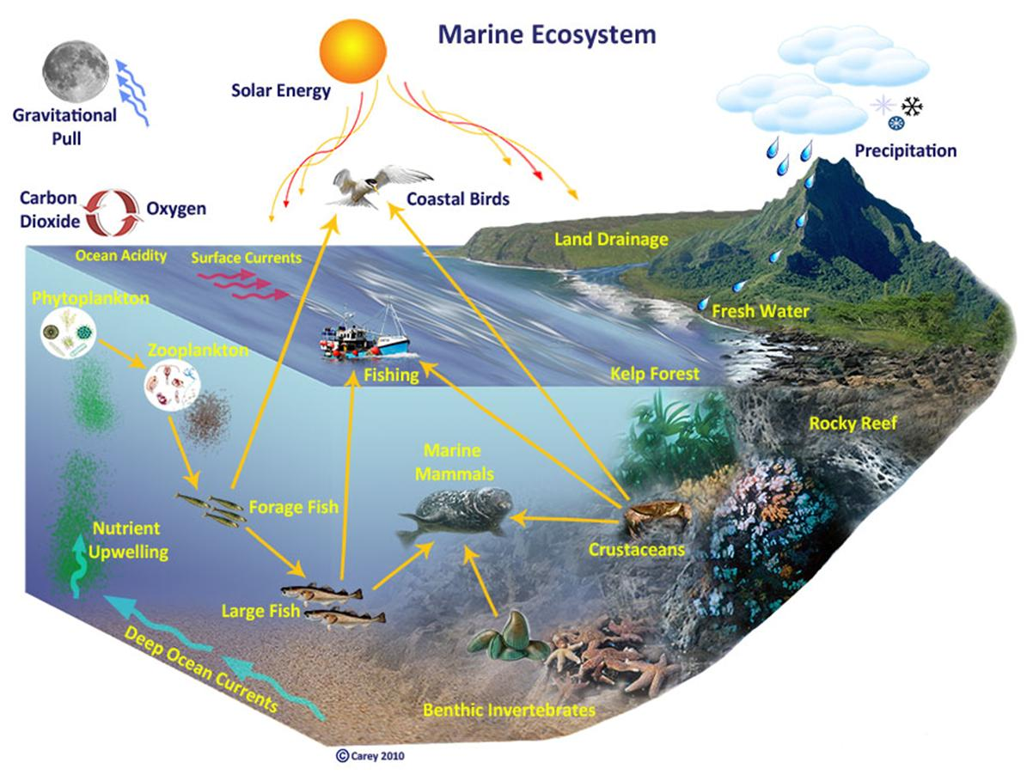

Figure 3.1. Generalised diagram of all the different elements that comprise an ecosystem.

### Activity 3.1: Brainstorm: ask students what comprises local marine ecosystems? (5 mins)

### *Supplementary discussion for more advanced students:* A marine ecosystem, in addition to the above, contains water, detritus and hundreds of thousands of different kinds of organisms, including bacteria, microscopic plants, microscopic animals, fish, mammals and birds. (Cury et al 2003).

### Ensure understanding of bacteria, phytoplankton (microscopic plants), zooplankton (microscopic animals).

### Discuss link between the coral animal and the algae living inside it (zooxanthellae). (10 mins)

### Food chains

Plants and animals are connected through what they eat. Some animals eat plants (herbivores), in turn, other animals may eat these herbivores (carnivores), in turn, other animals may eat the carnivores (also carnivores) and so on. Eating provides nutrients and energy for biological processes (e.g. growth, reproduction). The original source of (almost) all energy is the sun (the exception being deepwater hydrothermal vents which source energy from within the earth e.g. from underwater volcanic activity).

An example of a food chain is:

Sunlight -> marine plant (e.g. algae) -> parrotfish -> coral trout -> shark

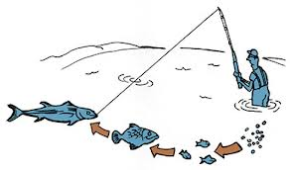

Figure 3.2. A simple food chain diagram with a fisherman ato the top of the food chain ([www.fish.wa.gov.au](http://www.fish.wa.gov.au)).

### Activity 3.2: Get students to choose a partner and write down on sticky note pads at least one example of a local food chain. (10 mins)

### Foodwebs

A foodweb describes the complex inter-linkages among all organisms in an ecosystem and are comprised of many different food chains.

### Activity 3.3: CONSTRUCT A FOOD WEB. Get students to write down a local marine organism (using local names if they wish) on a sticky note. They put this on their shirt and as a group the class stands in a circle with someone in the middle as the SUN. Using a roll of string the SUN wraps the string around their hand and throws the string to another organism and explains how they provide energy to that organism (eg. sea grass). The SEA GRASS person wraps the string around their hand and then throws the string to another organism and explains how they provide energy to that organism (eg. rabbit fish), and so on. Once the string ends at a top order predator (eg. shark, human) it starts again at the SUN.

### Once the food web is completed, to simulate fishing impacts the teacher chooses an organism that is fished too hard (eg. grouper) and that person drops down pulling the string. All string connections must be taut so that the effect of the grouper dropping down is felt by many other organisms in the food web. This should demonstrate the complexity of ecosystems and the inter-linkages among all the organisms within the ecosystem. That is, when one organism is affected everything else in the ecosystem is also affected. (25 mins)

### Supplementary discussion: Ask class to guess at scientists’ best estimates for the number of species inhabiting coral reef ecosystems? Answer: ~250 000 species from the Coral Reef component of the Census of Marine Life.

### Discuss the complexity of coral reef ecosystems and foodwebs.

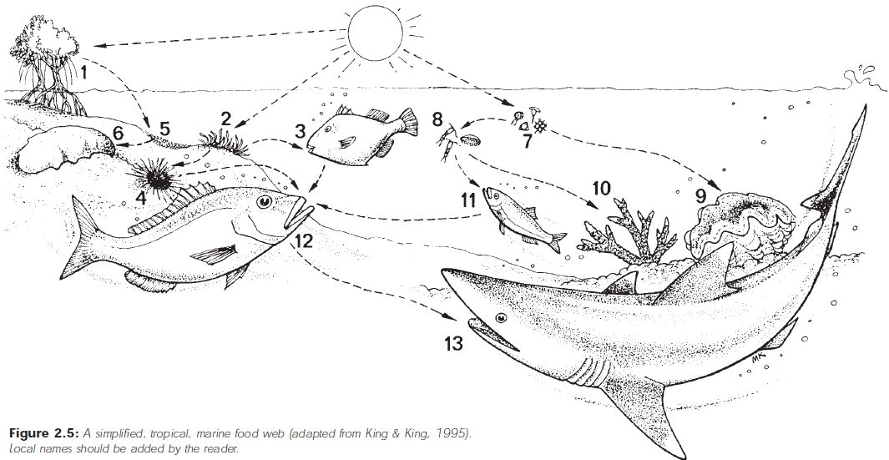

Figure 3.3. Example of a simplified tropical ecosystem foodweb. Source: King and King, 1995.

### Trophic levels

All organisms within the foodweb can be placed in trophic levels depending on what energy source they rely upon and how they provide energy for other organisms in food chains. Life is always (except near hydrothermal vents) dependent directly or indirectly on the energy from the sun. In every ecosystem, there is an organism at the lowest level that converts energy from the sun into useable energy for other organisms. The lowest trophic level is made up of plants, like phytoplankton, which are capable of transforming inorganic carbon into protoplasm and are called primary producers. Animals that consume primary producers in turn derive energy from eating that primary producer; these are called primary consumers. The more trophic levels present, the less energy is conserved at higher trophic levels (see Figure 3.4).

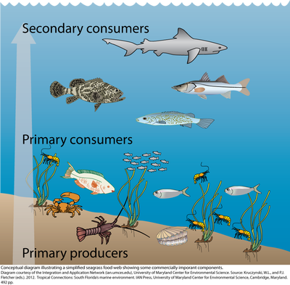

Figure 3.4. Simplified representation of different trophic levels in a tropical seagrass habitat.

Trophic levels:

* Level 1: Plants and algae make their own food and are called ***primary producers***.
* Level 2: Herbivores eat plants and are called ***primary consumers***.
* Level 3: Carnivores which eat herbivores are called ***secondary consumers***.
* Level 4: Carnivores which eat other carnivores are called ***tertiary consumers***.
* Level 5: [***Apex predators***](http://en.wikipedia.org/wiki/Apex_predator) which have no predators are at the top of the food chain

Animals that eat plants are called primary consumers or herbivores.

*Ask class for examples of primary consumers (e.g. zooplankton, fusiliers, rabbitfish, small angelfish, many surgeonfish, some shells e.g. trochus).*

Fish that eat herbivorous fish are called secondary consumers, or carnivores.

*Ask class for examples (e.g. coral trout, snapper).*

Animals that eat other carnivores are called tertiary consumers.

*Ask class for examples (e.g. shark, sea eagle)*

Animals at the top of the food chain with no predators include animals such as large sharks and killer whales.

Some animals eat plants and animals and are called omnivores

*Ask class for examples, e.g. triggerfish, pufferfish.*

Some animals also eat dead and decaying plant and animal material

*Ask class for examples e.g. sea cucumber (beche-de-mer), crabs, some shells.*

*Show trophic levels within the foodweb/food chains drawn.*

<http://www.teachoceanscience.net/teaching_resources/education_modules/coral_reefs_and_climate_change/why_are_predators_important/>

### Activity 3.5: Teacher to ask students to identify verbally the trophic level of their organism (from Activity 3.4). (5-10 mins)

### Energy pyramid

The food chain consists of trophic levels, or the levels within the food chain in which energy is transformed. Due to basic principles of thermodynamics, energy is always lost to the environment any time an organism at one trophic level uses the energy from the trophic level below. For example, the energy gained by animals that eat phytoplankton is less than the amount of energy initially available. Every trophic level loses energy, so trophic levels are often illustrated as a pyramid with primary producers forming the base. At the apex, or top, is the highest level consumer or top predator (see Figure 3.5).

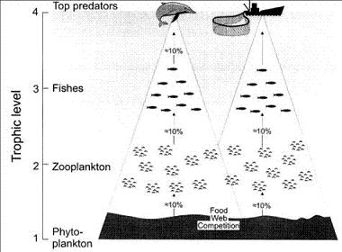

Figure 3.5. Diagram representing the transfer of energy through trophic levels of a marine food web. The higher up the food web the more energy lost from lower trophic groups.

This can be represented as an energy pyramid. This is shown in Figure 3.6 and how it links to trophic levels and food webs.

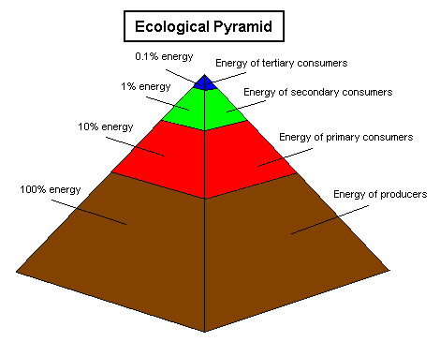

Figure 3.6. An energy pyramid demonstrating the energy loss as you move up the food chain.

This energy pyramid always shows a decrease in energy moving up trophic levels because:

* Only a certain amount of food is captured and eaten by organisms on the next trophic level.
* Some of food that is eaten cannot be digested and exits digestive tract as undigested waste.
* Only a portion of digested food becomes part of the organism's body; rest is used as source of energy.
* A substantial portion of food energy goes to build proteins, lipids, carbohydrates and to fuel growth and movement.

So it takes about 1000 grams (or 1kg) of plant energy to create one gram of, say, shark biomass (meat). So the energy “stored” in a living shark is a large amount of the ecosystem’s energy.

That also means eating 1 gram of “top predator” meat (e.g. shark) takes the same energy out of the system as eating 1000 grams of seaweed. Or eating 100grams of a herbivore (e.g. rabbitfish) takes the same energy out of the ecosystem as 1000grams of seaweed.

### Connectivity (see also section on “Movement” in Unit 5)

Plants and animals within an ecosystem can also be connected between habitats. For example, the Red Emperor (*Lutjanus sebae*) spends different parts of its life in different parts of the ecosystem. Adult male and female fish spawn on coral reefs producing millions of sperm and eggs into the water column. Once a single sperm fertilises one of the millions of eggs released during spawning the life of a Red Emperor begins. The egg hatches into a baby fish (larvae) which spends a few weeks eating other plankton and growing until it becomes more recognisable as a juvenile fish. It then moves inshore and spends some time, as a young fish, in the inshore seagrass beds. Once it gets larger and approaches maturity it starts moving offshore again to soft and hard seabed habitats. Once the fish becomes a mature adult the process starts again.

Other species, such as Spanish mackerel and tuna, can move large distances throughout their lives through different regions. This story, of how habitats and different parts of the ocean are connected by the fact that fish use different habitats at different stages during their lives, is just one of millions of such stories. And all the stories put together form the fabric of connectivity between habitats of tropical coastal marine ecosystems.

The connections also extend to the catchments where the quality of the water flowing into the sea is important to the survival of, for example, the coastal habitats such as mangroves and seagrasses which are used by larval and juvenile fish that often form part of coastal fisheries. Some reef species even use estuaries during different stages of their life, particularly juvenile stages.

*Use the red emperor connectivity poster here to demonstrate (Figure 3.7).*

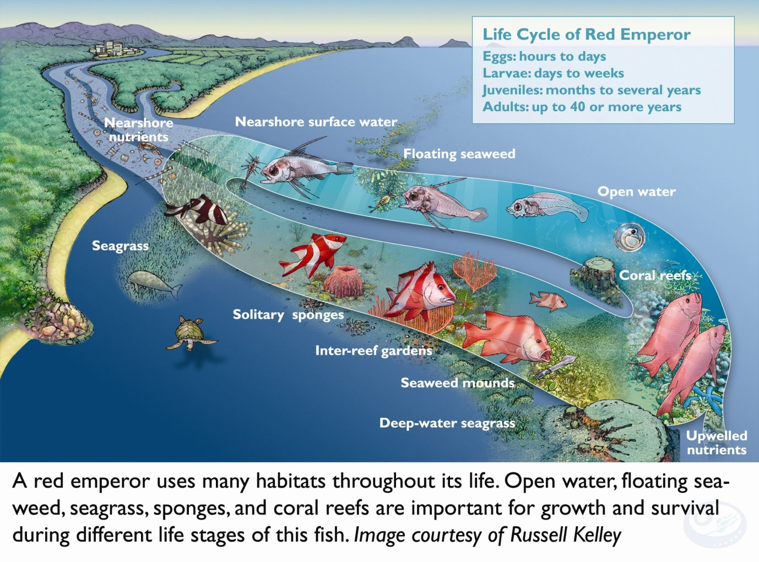Figure 3.7. Life cycle of the red emperor (*Lutjanus sebae*) showing the connectivity of different life history stages with different habitats across the continental shelf of the GBR. Source: Russell Kelley.

In an ecosystem approach to fisheries management it is therefore important to ensure maintenance of all habitats and species within an ecosystems as they are all reliant upon each other either in ways that we understand or, often, ways that we perhaps do not understand yet.

**Further reading:**

Student to read BACK side of Blue Highway poster.

Cury, P., L. Shannon, and Y.-J. Shin. 2003. **The functioning of marine ecosystems: a fisheries perspective**. Pages 103-125 *in* M. Sinclair and G. Valdimarsson, editors. Responsible fisheries in the marine ecosystem. FAO, Rome.

# Unit 4: Ecosystem Approach to Fisheries Management (EAFM)

## Student outcome: an understanding of an ecosystem approach to fisheries management and how it differs from other management approaches

**Activity 4.1: Break the class into groups of 3-6 students and ask them to discuss examples of the different types of management approaches used locally. Groups to present back to the class. (15 mins)**

### Conventional fisheries management

Historically, fisheries have been managed with a focus on controlling the human activity associated with fisheries using both input and output controls. That is, controlling what gears can be used, where and when they can be used (input controls) and controlling what is caught and how much (output controls). This conventional approach tends to focus on one target species, addresses only issues directly associated with the particular fishery, and has a top-down approach (government dominated). For several reasons we won’t go into here, there are many examples of the failure of conventional fisheries management.

### Derivation of ecosystem approaches

With the adoption of sustainable development as a core concept during the early 1980s, many sectors/disciplines started to look at approaches they could use to achieve sustainable development. Sustainable development strives to balance ecological well-being and human well-being (Figure 4.1).

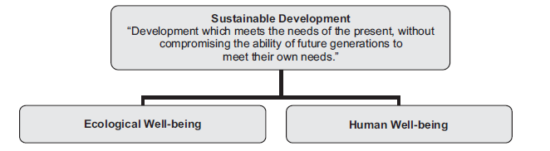

Figure 4.1. Sustainable development is a balance between ecological well-being and human well-being (Source: Staples and Funge-Smith, 2009).

This has led to multiple different types of management approaches based on the same principles with the two main differences among them being how the balance between ecological and human factors is achieved, and the number and scope of sectors being considered. EAFM is one such management approach.

***Defining EAFM***

Conventional fisheries management involves managing the target species and fishery in isolation of the wider ecosystem. However, other parts of the ecosystem are impacted by fishing and target species are impacted by factors other than fishing. An ecosystem approach to fisheries management combines conventional fisheries management with ecosystem management recognising that humans are part of the ecosystem. Therefore, although EAFM is generally the responsibility of fisheries agencies, the full implementation requires a cooperative approach with other agencies responsible for other activities that impact on the aquatic ecosystem (FAO, 2005). EAFM focuses primarily on managing fisheries, in a way that is consistent with the well-being of the wider ecosystem (both natural and human).

The CTI has adopted the FAO (2005) definition of the ecosystem approach to fisheries management:

***“An ecosystem approach to fisheries management is defined as striving to balance diverse societal objectives by taking into account the knowledge and uncertainties about biotic, abiotic and human components of ecosystems and their interactions and applying an integrated approach to fisheries within ecologically meaningful boundaries.”***

The aim of the ecosystem approach to fisheries management is to “plan, develop and manage fisheries in a manner that addresses the multiple needs and desires of societies, without jeopardizing the options for future generations to benefit from the full range of goods and services provided by marine ecosystem.” (FAO, 2003).

The key FAO principles that EAFM should address are that:

• fisheries should be managed to limit their impact on the ecosystem to an acceptable level;

• ecological relationships between species should be maintained;

• management measures should be compatible across the entire distribution of the resource;

• precaution in decision-making and action is needed because the knowledge on ecosystems is incomplete;

• governance should ensure both human and ecosystem well-being and equity.

***Advanced students***

### Convention on Biological Diversity Principles of the Ecosystem Approach

The wider principles identified by the Convention on Biological Diversity (CBD) for an ecosystem approach in any environment, terrestrial or aquatic, are also useful and are shown below. All the CBD principles are relevant and important in EAFM as well, and are consistent with the FAO list of principles in the previous paragraph.

Principle 1: The objectives of management of land, water and living resources are a matter of societal choice.

Principle 2: Management should be decentralized to the lowest appropriate level.

Principle 3: Ecosystem managers should consider the effects (actual or potential) of their activities on adjacent and other ecosystems.

Principle 4: Recognizing potential gains from management, there is usually a need to understand and manage the ecosystem in an economic context. Any such ecosystem management programme should:

a) reduce those market distortions that adversely affect biological diversity;

b) align incentives to promote biodiversity conservation and sustainable use;

c) internalize costs and benefits in the given ecosystem to the extent feasible.

Principle 5: Conservation of ecosystem structure and functioning, in order to maintain ecosystem services, should be a priority target of the ecosystem approach.

Principle 6: Ecosystems must be managed within the limits of their functioning.

Principle 7: The ecosystem approach should be undertaken at the appropriate spatial and temporal scales.

Principle 8: Recognizing the varying temporal scales and lag-effects that characterize ecosystem processes, objectives for ecosystem management should be set for the long term.

Principle 9: Management must recognize that change is inevitable.

Principle 10: The ecosystem approach should seek the appropriate balance between, and integration of, conservation and use of biological diversity.

Principle 11: The ecosystem approach should consider all forms of relevant information, including scientific and indigenous and local knowledge, innovations and practices.

Principle 12: The ecosystem approach should involve all relevant sectors of society and scientific disciplines.

More detail can be obtained from Decision V/6 of the fifth Conference of the Parties to the Convention on Biological Diversity at:

[www.biodiv.org/decisions/default.aspx?m=COP-05&id=7147&lg=0](http://www.biodiv.org/decisions/default.aspx?m=COP-05&id=7147&lg=0)

### How EAFM is different to conventional fisheries management?

EAFM is really an extension of conventional fisheries management, utilising the full range of conventional management tools (input and out controls), while broadening the scope of management to encompass multiple target species and factors that both directly and indirectly may impact the fishery. This includes the broader ecocystem as well as the social and economic dimensions of fisheries.

Table 4.1.Conventional and ecosystem approaches to fisheries management contrasted (Source: APFIC 2009).

|  |  |
| --- | --- |
| **Conventional approaches** | **Ecosystem approaches** |
| **Few** fisheries management objectives. | **Expanded scope** of fisheries management to  explicitly address ecosystem and socio-economic  considerations. |
| **Sectoral**, i.e. focuses mainly on fisheries sector issues. | Deals more explicitly with the interactions of the  fishery sector with **other sectors**, e.g. coastal  development, tourism, aquaculture, navigation,  petroleum industry. |
| Deals mainly with **target species**. | Responds to concerns of the **broader impacts of**  **fisheries** on the marine ecosystem, including impacts  on the habitat, on vulnerable species, on biodiversity  etc. |
| Addresses fisheries management issues at the **stock/fishery scale**. | Addresses the key issues at the **appropriate spatial**  **and temporal scales**. These are often nested (local,  national, sub-regional, regional, global). |
| Predictive, with decision-making mainly **based on results from mathematical or statistical models** that assess the outcomes of different management strategies. | Given the uncertainty associated with many of the  issues to be dealt with, because of limited data  availability and poor knowledge of relevant processes,  **adaptive** strategies are recognized as being more  useful. |
| Scientific knowledge is considered the **only** valid knowledge as a basis for decision-making. | Recognizing that it is not possible to obtain scientific  knowledge on all the issues to be dealt with,  alternative knowledge (e.g. **traditional knowledge**)  can be utilized as a basis for decision-making. |
| Operates through **regulations and penalties** for non-compliance. | **Encourages compliance with regulations through**  **incentives.** |
| **Top-down** (command and control) approaches typifies conventional fisheries management | **Participatory** approaches, e.g. various forms of  co-management are a key feature of EAFM. |
| Addresses **mainly corporate** (fisheries sector) interests. | Addresses the interests and aspirations of a **broader stakeholder community**. |

### Discussion: Discuss with the class Table 4.1 in the context of local marine tenure? How does *traditional* local management compare with EAFM? Students need to start thinking about how EAFM may be applied in a local context. (30 mins)

### Other management approaches

How does EAFM contrast to ICZM, EBM, MPAs, CBRM/co-management, the precautionary principle (see picture in (USAID US CTI Support Program, 2011)(Staples, 2009)). See also Preston 2009.

From Staples 2009:

When adopting sustainable development as a core concept, many sectors/disciplines started to look at how to achieve it (sustainable development). All the approaches used by the different sectors/disciplines have ended up with similar principles guiding them to achieving sustainable development with the two main differences being:

* the balance between ecological and human well-being, and
* the number and scope of the sectors (e.g. fisheries, agriculture, oil/gas, etc) being considered.

The following provides a few examples of different variations of the ecosystem approach developed by different groups.

***Ecosystem-based management (EBM)***

The main difference between EAFM and EBM is that while EAFM is primarily focused on managing a particular sector, EBM focuses on holistically managing entire ecosystems, integrating all of the sectors that are both influenced by the ecosystem or that impact the ecosystem. Hence, EBM necessarily requires inter-sectoral coordination focused on managing to sustain ecosystem function and well-being to provide ecosystem goods and services for society. However, as long as the impact of the environment on fishing, the impact of fishing on the environment and the socio-economic benefits that can be gained from fishing are considered, then the different terms may be interchangeable. Because human activities on land and in the ocean are changing coastal and marine ecosystems they threaten the ability of those ecosystems to provide important benefits to society, such as healthy and abundant seafood and protection from storms and flooding. EBM is a management approach aiming to address all these challenges. It considers the whole ecosystem, including humans and the environment, rather than managing one issue or one resource in isolation.

Key aspects of EBM include:

* Integration of ecological, social, and economic goals and recognition of humans as key components of the ecosystem.
* Consideration of ecological- not just political- boundaries.
* Accounting for the complexity of natural processes and social systems and using an adaptive management approach in the face of resulting uncertainties.
* Engaging multiple stakeholders in a collaborative process to define problems and find solutions.
* Incorporating understanding of ecosystem processes and how ecosystems respond to environmental perturbations.
* Concern with the ecological integrity of coastal-marine systems and the sustainability of both human and ecological systems.

***Integrated coastal zone management***

Generally focused on a particular coastal region of interest, Integrated Coastal Zone Management (ICZM) is a dynamic management process aiming at a sustainable social and economic development of coastal zones (tourism, agriculture, fishing, industry, maritime transport), taking into account the coastal ecosystems and landscapes, the diversity of activities and uses, their interaction and their impact on both the marine and land part of the coastal zone (Figure 4.2). It is also known as integrated coastal management (ICM), integrated coastal area management (ICAM), integrated coastal resource management (ICRM), coastal zone management (CZM), and in inland areas as integrated catchment management (ICM).

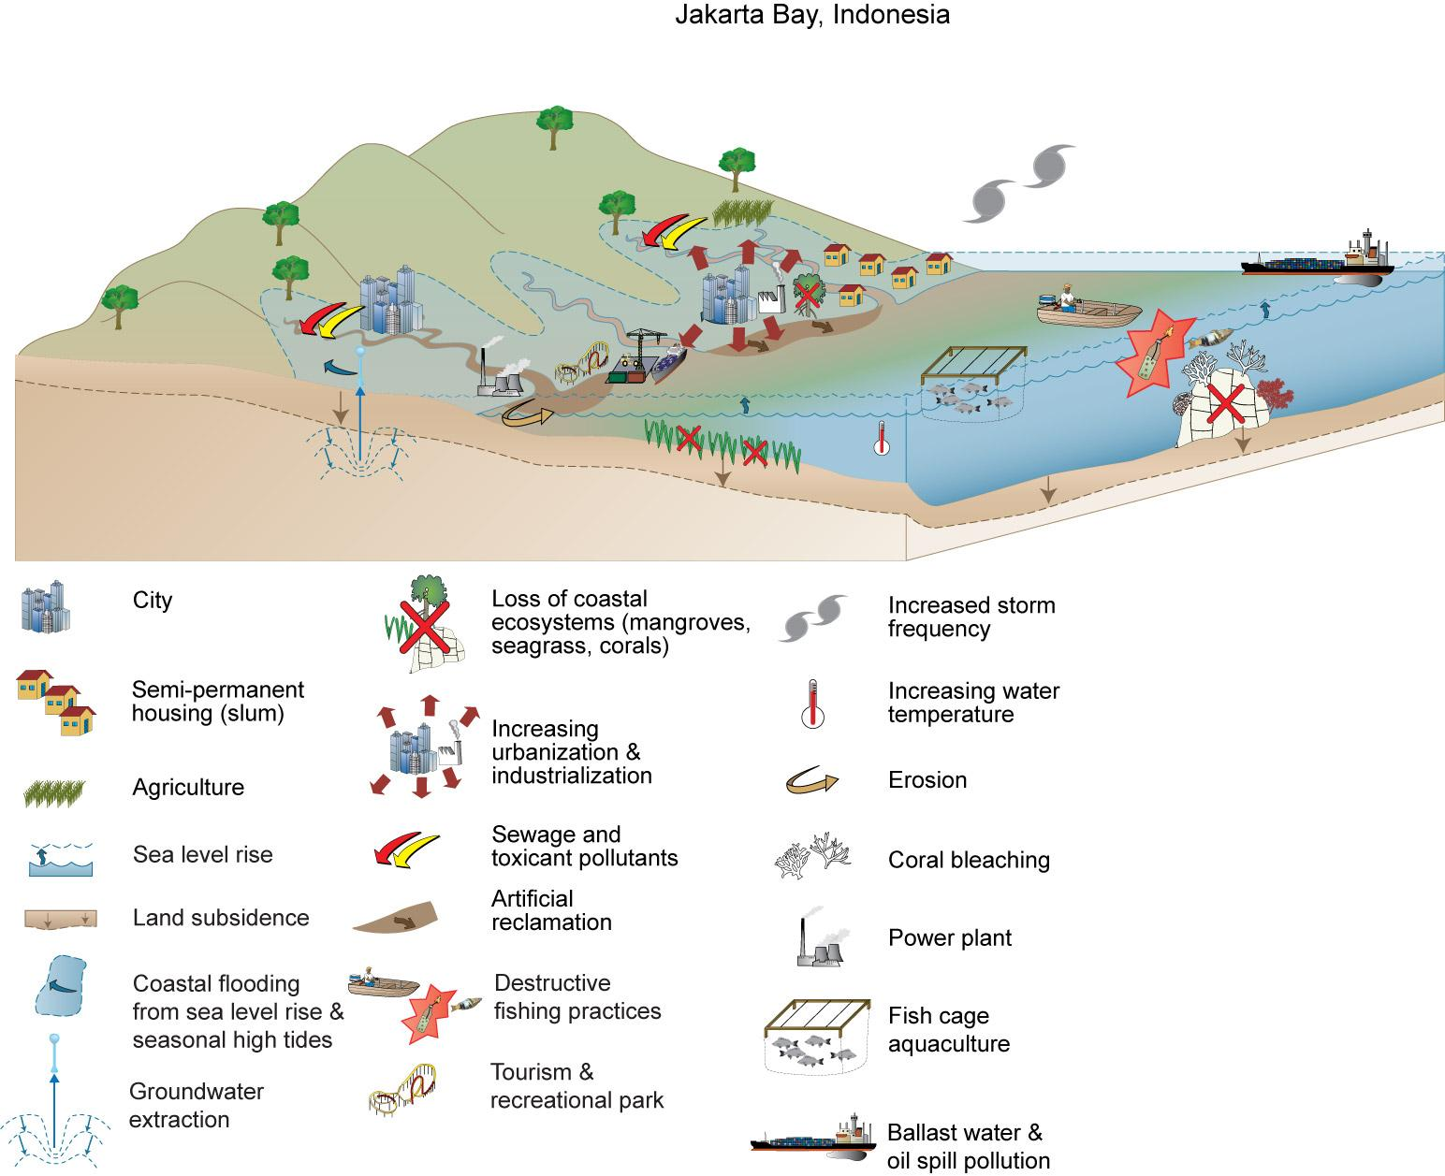

Figure 4.2. A typical landscape focus for Integrated Coastal Zone Management showing the types of issues that this approach attempts to manage.

***Co-management/Community-based resource management*** *(adapted from SPC 2010)*

Community-based resource management (CBRM), or co-management, refers to a management system under which communities take a leading role (or a bottom-up approach) in managing their resources including relevant land and sea areas in partnership with, or with support from, a promoting agency (Figure 4.3).

Communities in the Pacific Islands have been involved in managing and protecting their coastal ecosystems and fish stocks for many hundreds of years. And now, many government and NGOs are actively encouraging communities to take on more management responsibilities under CBRM projects. (See NFA 2007)



Figure 4.3. The shift from more conventional top-down government management approaches to the bottom-up community controlled management. Co-management is a negotiation among relevant stakeholders (Source: Govan et al, 2008).

***Advanced students:***

There is a separate curriculum and course under development within this project on Community Based Resource Management (CBRM) which can be undertaken by interested students. Also, see also Principles of CBRM from Solomon Islands (on the EAFM CD in the folder “Solomons Fisheries Information“ under References and Further Reading).

Table 4.2. Summary of key differences among the main management approaches described here.

|  |  |  |  |  |  |
| --- | --- | --- | --- | --- | --- |
|  | ***Management approaches*** | | | | |
| ***Management elements*** | **Conventional** | **EAFM** | **EBM** | **ICZM** | **CBRM** |
| **Ecosystem scale** | Per fishery | Multiple fisheries & wider ecosystems | Entire ecosystem | Terrestrial and marine coastal zone | Varied |
| **Geographic scale** | Local - regional | Local - regional | Regional – may cross jurisdictions | Regional | Local - regional |
| **Sectors** | Fishery | Principally fishery | All | All | Varied |
| **Governance** | Top-down | Shift to bottom-up | Shift to bottom-up | Shift to bottom-up | Bottom-up |
| **Objectives** | Ecological | Ecological, social and economic | Ecological, social and economic | Ecological, social and economic | Ecological, social and economic |
| **Management tools** | Input/output controls | Conventional & ecosystem tools, eg. MPAs | Conventional & ecosystem tools, eg. MPAs | Conventional & ecosystem tools, eg. MPAs | Conventional & ecosystem tools, eg. MPAs |

The Coral Triangle Support Partnership’s Ecosystem Approach to Fisheries Management Technical Advisory Group has illustrated the inter-linkages between these different but inter-related management approaches using the diagram shown in Figure 4.4.(USAID 2011)



Figure 4.4. Inter-relationships between the different management approaches available. Source: CTSP EAFM Technical Brief 2011

***Marine Protected Areas*** (from Fernandes et al 2012)

Marine protected areas (MPAs) are a management tool that can be used in any approach to marine resource management. MPAs are not just no-take areas; they encompass a range of types of protection. A marine protected area is included in IUCN’s definition of protected area which is “A clearly defined geographical space, recognised, dedicated and managed, through legal or other effective means, to achieve the long-term conservation of nature with associated ecosystem services and cultural values.” (Dudley 2008). IUCN/WCPA (1994) in (Sale, Van Lavieren et al. 2010)explicitly defined MPA as a means to protect part or all of the enclosed environment. Protected areas are distinguished from other kinds of marine spatial zoning in that they have nature conservation as a primary rather than a secondary aim (World Commission on Protected Areas - Marine 2010). The category VI protected areas explicitly have the sustainable use of natural resources as a *means* to achieve nature conservation (Dudley 2008). In this way, then, any clearly defined, managed area that contributes to protection of natural resources in some way is a marine protected area.

Therefore, marine protected areas can be used to describe locally managed marine areas, multiple use marine parks, marine spatial zoning, etc.

### Precautionary principle

The precautionary principle means that “where there are threats of serious irreversible damage, lack of full scientific certainty shall not be used as a reason for postponing cost-effective measures to prevent environmental degradation” (FAO 2003).

It applies to all the management tools and approaches discussed above with the exception of more conventional, scientific approaches to fisheries management. More than ever, ecosystem approaches to management necessitate the use of the precautionary principle through:

* use of the best available knowledge.
* acceptance that information requirements will be incomplete.

For example, the PNG National Beche-de-mer Management Plan explicitly advocates the use of the precautionary principle saying: “Precautionary Approach” means setting down restrictions to control harvesting in absence of adequate scientific data. These restrictions include setting of TAC, seasonal and area closure and control fishing efforts.

### Activity 4.2: Form small groups and decide on how an EAFM may be applied to a specified area that is consistent with local custom. Report back to class explaining why. (15 mins)

**Further reading:**

NFA (2007) Community-based fisheries management: a training manual for workers involved in community-based management. National Fisheries Authority and Coastal Fisheries Management and devlopment Project, 2007. Kavieng, Papua New Guinea.

CTSP EAF Technical Working Group. 2012. Coral Triangle Regional Ecosystem Approach to Fisheries Management (EAFM) Guidelines Page 33. CTSP, Jakarta.

FAO (2003) Fisheries management. 2. The ecosystem approach to fisheries. FAO Fisheries Technical Guidelines No. 4, Suppl. 2, Food and Agriculture Organization of the United Nations, Rome.

FAO (2005) Putting into practice the ecosystem approach to fisheries. Food and Agriculture Organization of the United Nations, Rome, 2005, 76pp.

Fernandes, L., A. Green, J. Tanzer, A. White, P. M. Alino, J. Jompa, P. Lokani, A. Soemodinoto, M. Knight, B. Pomeroy, H. Possingham, and B. Pressey. (2012) Biophysical principles for designing resilient networks of marine protected areas to integrate fisheries, biodiversity and climate change objectives in the Coral Triangle. Coral Triangle Support Partnership, Jakarta. Executive Summary only.

Govan, H., Aalbersberg, W., Tawake, A., and Parks, J. (2008) Locally Managed Marine Areas: A guide for practitioners. The Locally-Managed Marine Area Network.

Staples, D. And S. Funge-Smith. 2009. Ecosystem approach to fisheries and aquaculture: implementing the FAO Code of Conduct for Responsible Fisheries. RAP Publication 2009/11, FAO Regional Office for Asia and the Pacific, Bangkok.

USAID US CTI Support Program, (2011) An Ecosystem Approach to Fisheries Management (EAFM) and the Coral Triangle Initiative. Technical brief.

# Unit 5: Fish biology

## Student outcome: understanding of the life history characteristics that are important for fisheries management

### Activity 5.1: Ask students to identify the processes that lead to changes in fish populations. (3 mins)

### Population dynamics

Population dynamics describes how a population changes in size through time. The dynamics of fish populations or stocks is described by a simple equation called Russell’s Axiom (Russell 1931):

*Stock size1 = Stock size0 + (Recruitment + Growth) – (Natural mortality + Catch)*

Where *Stock size1* is the number or biomass of fish at time 1 (eg. next year), *Stock size0* is the number or biomass of fish at time 0 (eg. this year), *Recruitment* is the number that are born and become part of the population, *Growth* is the increase in size/weight an individual, *Natural mortality* is the number or weight of fish dying of natural causes, and *Catch* is the amount that is caught by fishing (Figure 5.1).



Figure 5.1. Representation of the dynamics of fish populations showing biomass increases due to growth and recruitment, and biomass decreases due to mortality (natural and fishing). Source: King (1995).

This equation is the basis for understanding changes in fishery patterns with three main functions:

*Birth rate (recruitment)* – the number of new young fish that enter a population each year. In fisheries this usually refers to the size when they are able to be captured by the fishery and is important in replenishing fish stocks.

*Growth rate* – measured as the gain in weight and/or length throughout their life. This is important in fisheries in terms of the fish biomass available for capture and replenishing that taken out of the population by fishing.

*Mortality* – this is made up of fishing mortality and natural mortality.

### Activity 5.2: Ask students to identify the different reproductive strategies in local marine animals. Teacher to write these on a flip chart. (5 mins)

### Reproduction

**Reproduction**

Marine animals display a diverse range of reproductive strategies which have differing implications for population recruitment. This in turn has different implications for what management strategies are appropriate. Examples of modes of reproductions are:

***Broadcast spawners***

These are animals that release gametes (sperm and eggs) into the water column. Fertilised eggs develop into larvae and drift/swim in the water column as plankton for period ranging from approximately 1 week to 6 months or more. Most marine fish use this strategy and spawn either in pairs, small groups and sometimes large spawning aggregations. Invertebrate species also use this strategy including corals, clams and beche de mer species. Species using this strategy can also have multiple spawnings in each year and are capable of producing thousands or even millions of larvae. However, mortality rates for larvae vary enormously and can be very high in some years.

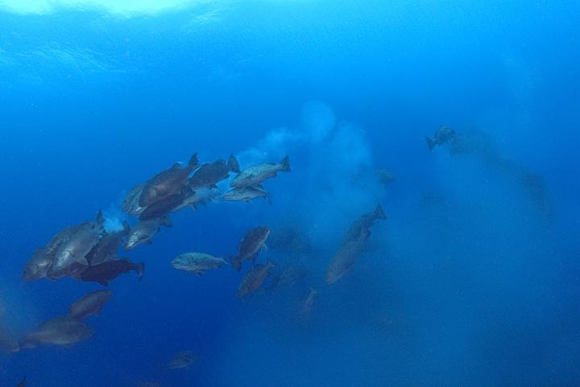

Figure 5.2. Examples of broadcast spawners: sea cucumber (left) and snapper spawning aggregation (right).

***Live young bearers***

Many animals give birth to live young after developing for long periods of time within the mother. These animals tend to produce only relatively few offspring however they are well developed and able to swim well and feed, and so survival is relatively good. Examples are several shark species, whales, and dugong.

***Egg-layers***

These are animals that lay eggs however there is a diversity of strategies among egg layers. Turtles bury their eggs on beaches to incubate them; some fish species lay demersal eggs and tend to them; and some fish species actually carry their eggs in their mouths until hatching. This strategy tends to produce a low number of offspring per individual and mortality during early development can be very high.

***Asexual***

Some animals reproduce asexually whereby parts of the animal are broken off (fragmentation) or the organism splits (fission) and the new part regenerates into a living organism. Examples of animals that use this strategy are corals, sponges and some beche-de-mer species.

### DVD: Fish and People – Module 2: Where do fish come from? (12 mins).

### Recruitment

The recruitment processes in marine animals will vary depending on their reproductive strategy. Regardless of the strategy the timing of spawning and larval development is very important. A species spawning season will usually coincide with periods of favourable environmental conditions for the survival of their offspring. However, the marine environment is highly variable and life in the plankton in particular is tough. Success of larval recruitment is linked to a temporal alignment of fish reproducing, larvae hatching, and plankton (prey) abundance (Match-Mismatch hypothesis; Cushing, 1974), and directly influences the size of fishery populations. In years of high larval survival subsequent recruitment to the fishery means good fishing years. This is why even without fishing occurring fish populations will naturally vary in number from year to year.

Maintaining healthy populations of adult fish (spawning biomass) is critical to ensuring enough offspring are produced to withstand the bad years and prevent the fishery from collapsing. Research has demonstrated that as fish size increases their fecundity (number of eggs produced) increases exponentially. Also, larger and older fish have been shown to produce more robust larvae. It is therefore important to maintain fish populations that have adequate spawning biomass that includes large individuals.

### DVD: Fish and People Module 3: How to make fish (12 mins).

### DVD: SCRFA spawning aggregations (2.5 mins).

### Activity 5.3: Ask students to identify reasons why an animal may die. (3 mins)

### Mortality

Mortality in marine populations can be due to either natural factors (M) or due to fishing (F). Natural factors include disease, predation by other species or old age. Natural mortality is something we have very little control over, however fishing mortality is something we can control. As discussed in Unit 2 there are a number of ways of doing this including:

* Controls on the total amount of fishing effort (eg. limits on the number of boats or people).
* Controls on the total amount of catch.
* Controls on where and/or when fishing is allowed.
* Controls on the sizes of fish allowed to be caught.

### Productivity

Productivity represents the capacity for a population to replenish itself and involves several processes. In general a highly productive stock is one that has a high rate of turnover of generations. This can be influenced by the key processes of recruitment, growth, maturation, longevity and mortality. For example, sardines are early maturing, highly fecund, fast growing fish with high mortality rates that only live for a year or two. This is the “live fast, die young” mode. This means that what we take out of the population by fishing has the capacity to be replaced the following year because what is not caught will produce recruits that grow fast enough and mature early enough to become available to the fishery the following year.

In contrast, some cod species are slow growing, mature at an older age, and therefore don’t recruit to the fishery until several years after being born. These species tend to be longer lived also. In this case replenishing populations can take several years, particularly after heavy fishing. In either situation the most important thing is to maintain enough animals in the population for spawning, and enough large individuals, to ensure enough recruitment in subsequent years. Simply knowing the longevity, or maximum age a species reaches, can provide a very reasonable indication of their productivity.

### Activity 5.4: Put students in groups of 4-6 and ask them to write on butchers paper and place different species according to how productive they are. Use the productivity groupings: most productive, moderately productive, least productive. Use the following species: grey reef shark, coral trout, cuttlefish, grouper, white tip reef shark, sea cucumber, turtle, anchovy, stingray, snapper. Students can add their own if they like. Groups to present to class and explain their groupings. (20 mins)

### (Most: anchovy, cuttlefish; Moderate: grouper, coral trout, sea cucumber, snapper; Least: grey reef shark, white tip reef shark, stingray, turtle).

### Use of SPC fact sheets are very useful for this activity <http://www.spc.int/images/publications/en/Divisions/Fisheries/Anon_11_Guide_InfoSheetsForCommunities.pdf> also on CD: SPC 2011

### List of taxonomic fact sheets available includes:

### Finfish Invertebrates

### 1. Groupers (Epinephelidae) 9. Sea cucumbers (Holothurians)

### 2. Rabbitfish (Siganidae) 10. Giant clams (Tridacnidae)

### 3. Emperors (Lethrinidae) 11. Trochus (*Tectus niloticus*)

### 4. Parrotfish (Scaridae) 12. Mangrove crab (*Scylla serrata*)

### 5. Reef snappers (Lutjanidae) 13. Spiny lobsters (Palinuridae)

### 6. Trevallies (Carangidae) 14. Coconut crab (*Birgus latro*)

### 7. Mullets (Mugilidae) 15. Octopuses

### 8. Surgeonfish (Acanthuridae) 16. Green snail (*Turbo marmoratus*)

***Advanced students***

### Sustainable yield

The concept of sustainable yield is driven by Russell’s Axiom. Sustainable yield, or catch, is the level of catch that can be taken from a population indefinitely. Maximum Sustainable Yield (MSY) has long been used in fisheries around the world to try and maximise how much is caught, however this approach has several key assumptions and its use has led to several fishery collapses. This has generally been used in a single species management approach but for the purpose of this course understanding the principles behind MSY is more useful than trying to measure and/or attain it.

Figure 5.1 shows a representation of Russell’s Axiom and plots sustainable catch for different sizes of the fishery stock or population. What this tells us is that once we begin to fish a stock down from its initial unfished state (right hand side of the plot) then at the lower density the population productivity actually increases to a maximum point (MSY). This is because as we increase fishing and remove fish from the population, we reduce the stock size, and for the fish remaining there is more space and food available which results in an increase in population growth. A continued increase in fishing effort eventually reduces the population size to a point where recruitment is compromised as there are fewer individuals for reproduction and the amount of catch that can be sustainably taken decreases.

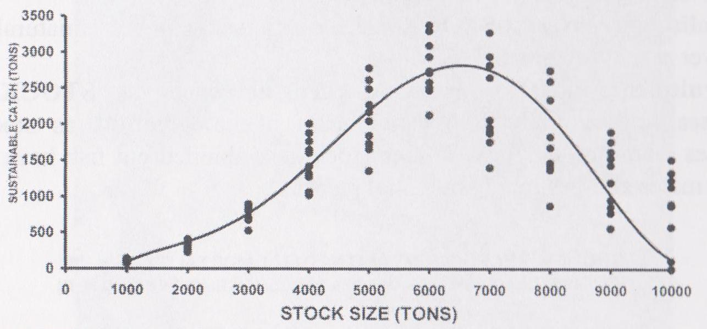

Figure 5.1. The relationship between stock size versus sustainable catch assumed under Russell’s Axiom.

The reason conventional fisheries management attempts to achieve maximum sustainable yield have usually failed are many:

* inadequate data,
* political decisions over-riding scientific advice,
* the low power of many fisheries data analysis such that one can only identify when one has gone OVER MSY after it has occurred (which is often too late for the sustainability of the fishery)
* natural variability which makes identification of MSY often impossible combined with the tendency for fisheries managers (and politicians) to err on the side of allowing more take (versus less take) if the data are ambivalent.

### Activity 5.5: Ask students to identify local species that are resident and those that are transient. (Explain definitions). Each student to write examples of each on sticky notes and place them on a flip chart under the headings: resident, transient. (7 mins)

### The role of movement (see also section on Connectivity in Unit 3)

The movement of individual organisms varies enormously among species and is critical in shaping the ecological processes that maintain ecosystem functioning. Movement can be at different spatial scales (ranging from metres to 1,000’s of km’s) and temporal scales (eg. diurnal movements in the water column, seasonal spawning aggregations, annual migrations) and can involve different life history stages. These movements are what determine the connectivity within and among groups of species making up an ecosystem.

At a species level understanding the level of connectivity among individuals helps to manage these populations appropriately. Consider this example: Imagine a local fish species important for your community and your village agree to impose strict catch limits due to concerns that numbers have been decreasing year after year. Imagine also that this species migrates in Spring every year to aggregate for spawning in the fishing grounds of a neighbouring community who don’t have any catch limits and target the fish when they are gathered for spawning. This situation would likely result in your own imposed management being ineffective and catches by your village (and your neighbours) would continue to decrease. Simply having the knowledge of this annual movement and sharing the information with neighbouring communities who target them, can result in co-ordinated efforts to apply management that ensures the species is not depleted and both communities can continue to catch this species into the future.

This demonstrates what in fisheries is called the unit stock, which although it can be defined in many ways, refers to “an intraspecific group of randomly mating individuals with temporal or spatial integrity” (Ihssen et al., 1981). In other words, a stock is a group of animals belonging to the same species that share the same geographic area throughout their lifetime. Knowledge of stocks and their structure for target species is viewed as the basis for any fishery analysis (Cadrin et al., 2005).

***Advanced students***

### Activity: Explain the above hypothetical situation and ask the class for suggested strategies that may be used to overcome the issue described above. Eg. extend the management area by negotiation/consultation; develop a management plan to protect the spawning aggregation (temporal and/or spatial closure), etc.

Movement can occur at different life history stages of animals. Movement of adults in marine species has been extensively studied. Some species are fairly sedentary and set up territories in reef habitats. Examples of these species are some serranids such as coral trout and cods. Other species are transitory in nature and may only temporarily pass through an area. Examples of these species include pelagic species like mackerels and tunas. Movement at the larval stage has been far less studied due to the challenges in working with such tiny animals. However, this area of study is particularly important for establishing connectivity among otherwise sedentary populations of fish, and in assessing the effectiveness of marine protected areas. It is well established that no-take marine reserves (NTMR) can hold more fish and larger more fecund fish. The benefit of such areas to adjacent areas where fishing occurs can be either through adult fish moving outside the NTMR boundaries (spillover effect), or by increased larval production and recruitment to areas outside the NTMR (Figure 5.3). This latter strategy requires movement of larvae. Studies have shown that coral reef fish larvae, although tiny and subjected to strong currents, exhibit clear behavioural patterns and many have strong swimming capabilities.



Figure 5.3. The role of movement among the different life history stages of a particular species in the context of a no-take marien reserve (NTMR). Source: King (1995).

### Activity 5.6: Ask students to answer the following questions in their notebooks under the heading ‘Activity 5.6’. Questions: What are differences between ecosystems and populations? Write in notebooks why foodwebs, energy pyramids and movement matter to fisheries management. (25 mins)

### Importance of life history in EAFM

Very few fisheries are so selective that they only catch a single species. Most fisheries affect many species and especially in the tropics fisheries are generally multi-species, either as target species or bycatch species. However, as discussed previously, some species are more productive than others. This means that in multi-species fisheries some species will be more vulnerable to fishing and will also take longer to recover from fishing. Multi-species fisheries ultimately alter the species assemblage of ecosystems either directly through removal of fish or indirectly through modification to habitats. In an EAFM context, management measures and associated objectives need to take into account low productivity species as well as high productivity species.

### DVD: Fish and People Module 4: Larval lifeboats near and far. (12 mins).

### Homework: Answer the following questions in your notebook:

### Q1. What are the four population processes that contribute to changes in a population?

### Q2. What are three different modes of reproduction in animals that live in marine ecosystems? Rank them in order from most productive to least productive in terms of fishing that they could support.

**Further reading:**

King, M. 2007. Fisheries biology, assessment and management. 2nd Ed., Oxford, UK, Wiley-Blackwell Publishing. 382 pp.

SPC (2011) Guide to information sheets on fisheries management for communities. SPC, Noumea, New Caledonia. also available at: <http://www.spc.int/images/publications/en/Divisions/Fisheries/Anon_11_Guide_InfoSheetsForCommunities.pdf>

1. On EAFM CD
2. Not on EAFM CD – contact leannef@earth2ocean.com
3. Not on EAFM CD